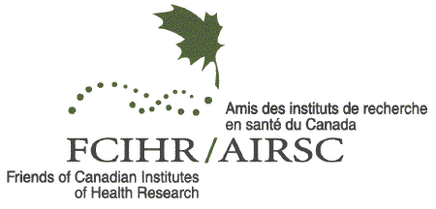
The Henry G. Friesen International Prize
in Health Research

2023 Nomination Form

The Prize:
The Henry G. Friesen International Prize was established in recognition of the leadership, vision and innovative contributions of Dr. Henry G. Friesen in Medical Research and Health Research Policy. The Friesen Prize Program serves to promote the value of scientific knowledge as a benefit to society at large.
Nominees shall be individuals whose work in health-related fields has gained international recognition and skilled in explaining to peers and the public the significance, challenges and opportunities in health research.
The Prize provides a cash award and travel costs and supports an annual Public Lecture as well as Institutional visits. FCIHR has collaborated with the Canadian Academy of Health Sciences (CAHS) and other Science-based Institutions in this venture. A detailed description, Terms of Reference of The Prize and obligations are available at: http://www.fcihr.ca/prize/about/nomination

Nominee: _____________________________________________________________

Address: ____________________________________Postal Code/Zip:_______________________

Phone: ( )____________________ E-Mail: ________________________________________

Basis of the Nomination:
Please provide key information regarding the nominee’s career and stature, major contributions to health research, health policy and care and other distinguishing accomplishments.

Primary Nominator: Secondary Nominator:

Name: __________________________________ ________________________________
Signature: ______________________________________ ______________________________________

Date: ___________________________________ ________________________________

Phone: _______________________________ _____________________________

E-Mail: __________________________________ ________________________________

The following additional information is required to accompany this form:

- Curriculum Vitae and List of Publications of the Nominee
- Letters of endorsement from both nominators
- Any other printed or electronic material that directly speaks to the nomination

Send the completed Nomination Package including a USB stick by Wednesday, June 1, 2022 marked Confidential to the attention of:

The Henry G. Friesen International Prize in Health Research
Advisory Committee

4 Devonshire Place, Toronto, Ontario, M5S 2E1

