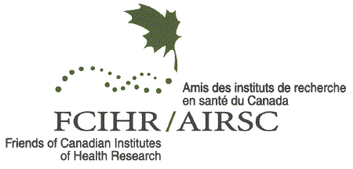 | INVOICE
Friends of Canadian Institutes of Health Research  820 Sherbrook Street  Winnipeg MB R3A 1R9 | INVOICE # 09-07  Date: July 30, 2026
P: (204) 787-3794
F: (204) 787-3279
E: fcihr@fcihr.ca

To: | [Name]  [Company Name]  [Street Address]  [City, ST ZIP Code]

 | payment terms | Payment deadline:
* Keep a copy of this invoice for your records | Due in full on receipt | September 6, 2007

description | total
2007 Annual General Meeting
Registration for the 2007 FCIHR Annual General Meeting: | $ 25.00
Thursday, September 20th, 2007; Debussy Room, Delta Montreal
Total | $ 25.00
Make your cheque payable to: Friends of CIHR
Mail to: AGM Registration, 820 Sherbrook Street, Winnipeg MB R3A 1R9
Thank you !

